**Steps to do before running calculations:**

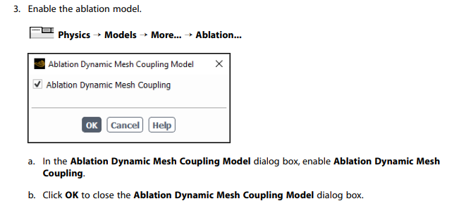

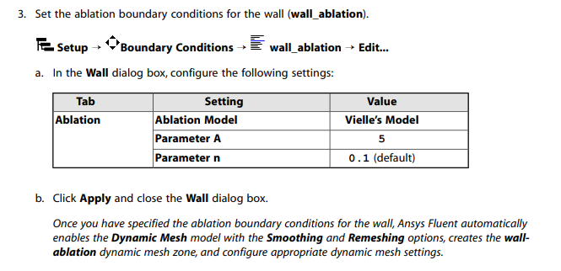

Enable the movement of the adjacent boundary layer mesh with the moving face zone for the wall_ablation dynamic zone

